

**Net Programming**

Final course report on

**“Material Inventory Management System”**

Created by

**PATWARY MOHAMMAD SAZZAD HOSSAIN (张一明)**

ID: 1911521212

Class: 19lq

Under The Guidance of

**Chen Qiong**

Associate professor

**Department of Computer Science & Technology**

**Hubei University of Technology**

**Wuhan, Hubei, P. R. China**

**May 31, 2023**

Contents

**ACKNOWLEDGEMENT** 3

**Abstract** 4

**Chapter 1: Introduction** 5

1.1 General Purpose 5

1.2 Significance 6

1.3Literature Review 8

1.4 Methodology 9

1.5 Organization of the paper 10

**Chapter 2: Requirements** 11

2.1 Basic Information Requirement 11

2.2 Implemented functions Requirement 12

2.2.1 Input of basic information about materials 12

2.2.2 Query and modification of basic material information 12

2.2.3 Input of inbound material information 12

2.2.4 Query and modification of inbound material information 12

2.2.5 Input of outbound material information 12

2.2.6 Query and modification of outbound material information 13

2.2.7 Query of material balance information 13

2.2.8 Browsing of material balance information 13

2.2.9 Exit from the system 13

2.3 Hardware and Software Requirement 14

2.3.1 Hardware Requirement 14

2.3.2 Software Requirement 14

**Chapter 3: Code Implementation** 15

3.1 Input of basic information about materials 15

3.2 Query and modification of basic material information 15

3.3 Input of inbound material information 16

3.4 Query and modification of inbound material information 17

3.5 Input of outbound material information 18

3.6 Query and modification of outbound material information 18

3.7 Query of material balance information 19

3.8 Browsing of material balance information 19

3.9 Exit from the system 20

**CHAPTER 4: Code Compile** 21

4.1 Input of basic information about materials 21

4.2 Query and modification of basic material information 22

4.3 Input of inbound material information 23

4.4 Query and modification of inbound material information 24

4.5 Input of outbound material information 25

4.6 Query and modification of outbound material information 26

4.7 Query of material balance information 27

4.8 Browsing of material balance information 28

4.9 Exit from the system 29

**CHAPTER 5: Conclusion** 30

# ACKNOWLEDGEMENT

I would like to extend my sincere gratitude to **Assoc. Prof. Chen Qiong**, who served as my project's advisor, for her unflinching guidance and support throughout the course of my project's development. Her knowledge of web development has been helpful in guiding me through the difficulties I have encountered, and her persistence and encouragement have been crucial in keeping me motivated throughout the project. I consider myself quite lucky to have had a teacher who has been so supportive and committed to me, and I appreciate everything she has done for me. **Associate Professor Chen Qiong**, you are appreciated for your superb mentoring and for making this research a success.

# Abstract

The Material Inventory Management System (MIMS) is a crucial component of modern supply chain management, providing organizations with efficient tracking, monitoring, and control of materials. Effective inventory management is essential for optimizing inventory levels, reducing costs, and ensuring the availability of materials for seamless operations.

The Material Inventory Management System offers a range of features and benefits. It enables businesses to streamline inventory processes, minimize stock outs, and improve customer satisfaction. Key functionalities include accurate inventory tracking, real-time stock monitoring, automated replenishment processes, and integration with procurement and production systems. Leveraging technologies such as barcode scanning, RFID, and advanced data analytics, MIMS facilitates efficient material handling and reduces manual errors.

Additionally, MIMS provides valuable insights through comprehensive reporting and analytics features. Organizations can generate reports on key performance indicators (KPIs), such as inventory turnover, stock accuracy, and lead times. These insights drive data-driven decision-making, optimizing inventory levels, forecasting demand, and identifying areas for improvement.

Implementing a Material Inventory Management System brings several benefits. It improves inventory accuracy, reduces carrying costs, prevents stock outs and overstocking, and minimizes wastage. Furthermore, it enhances supplier relationships by facilitating better demand forecasting and timely procurement. Ultimately, MIMS contributes to improved operational efficiency, cost savings, and increased profitability.

In conclusion, the Material Inventory Management System plays a vital role in optimizing inventory processes and ensuring the smooth flow of materials within organizations. With its comprehensive features, accurate tracking, and powerful analytics capabilities, MIMS empowers businesses to make informed decisions, streamline operations, and gain better control over their inventory management.

# Chapter 1: Introduction

## 1.1 General Purpose

The general purpose of the Material Inventory Management System (MIMS) is to provide organizations with an efficient and comprehensive solution for managing and controlling their material inventory. MIMS aims to streamline the entire process of tracking, procuring, storing, and utilizing materials, thereby optimizing resource allocation, minimizing costs, and enhancing overall operational efficiency.

Efficient inventory management is critical for organizations across various sectors, including manufacturing, retail, logistics, and healthcare. Poor inventory control can lead to issues such as stock outs, overstocking, increased holding costs, inefficient resource utilization, and disrupted supply chains. MIMS seeks to address these challenges by offering a centralized system that automates and streamlines inventory-related tasks.

With MIMS, organizations can accurately track the movement of materials, monitor stock levels in real-time, and generate reports on inventory status and trends. This enables better decision-making in procurement, ensuring that materials are available when needed while avoiding unnecessary excess. By optimizing inventory levels, organizations can reduce carrying costs and enhance cash flow.

Furthermore, MIMS facilitates efficient resource allocation by enabling organizations to identify underutilized materials and redistribute them to areas where they are needed the most. This helps minimize waste and maximizes the value of existing inventory.

The significance of implementing a Material Inventory Management System is evident in the potential benefits it offers. It improves customer satisfaction by reducing stock outs, increases operational efficiency by streamlining inventory-related processes, and enhances financial performance by optimizing resource allocation and reducing holding costs.

In conclusion, the Material Inventory Management System (MIMS) serves the general purpose of providing organizations with a comprehensive solution for managing and controlling their material inventory .By optimizing inventory levels, streamlining processes, and enhancing resource allocation, MIMS contributes to improved operational efficiency, reduced costs, and enhanced customer satisfaction.

## 1.2 Significance

The Material Inventory Management System (MIMS) holds significant importance for organizations across various industries. Efficient management of material inventory is crucial for achieving operational excellence and maintaining a competitive edge. Here are some key aspects highlighting the significance of implementing a Material Inventory Management System:

Cost Reduction: Effective inventory management through MIMS can significantly reduce carrying costs associated with excess stock, storage, handling, and obsolescence. By optimizing inventory levels and minimizing stock outs, organizations can improve cash flow, lower holding costs, and eliminate the need for emergency purchases at inflated prices.

Enhanced Operational Efficiency: MIMS streamlines inventory-related processes, automating tasks such as tracking, procurement, and stock reconciliation. This results in improved operational efficiency, as manual efforts are minimized, data accuracy is increased, and real-time inventory visibility enables better decision-making. Streamlined workflows also save time and effort, allowing employees to focus on value-added activities.

Improved Customer Satisfaction: Maintaining adequate stock levels and fulfilling customer orders promptly is crucial for customer satisfaction. MIMS enables organizations to accurately track inventory, monitor demand patterns, and forecast future requirements. With optimized inventory levels and improved order fulfillment rates, organizations can reduce stock outs, prevent delayed deliveries, and enhance customer satisfaction and loyalty.

Supply Chain Optimization: Efficient inventory management has a direct impact on supply chain performance. MIMS helps organizations collaborate with suppliers, ensuring timely procurement and replenishment. By integrating with other systems such as Enterprise Resource Planning (ERP), Customer Relationship Management (CRM), and Warehouse Management Systems (WMS), MIMS enables seamless information flow, coordination, and optimization across the entire supply chain.

Data-Driven Decision Making: MIMS provides valuable insights and analytics through comprehensive reporting and analysis capabilities. Organizations can gain a better understanding of inventory trends, demand patterns, supplier performance, and overall inventory health. Data-driven decision-making empowers organizations to make informed choices, improve forecasting accuracy, identify cost-saving opportunities, and optimize resource allocation.

Regulatory Compliance: In industries with strict regulations, such as healthcare, pharmaceuticals, and food, MIMS ensures compliance with inventory-related guidelines. It enables organizations to track and trace materials, maintain proper documentation, and ensure product quality and safety.

In summary, the significance of implementing a Material Inventory Management System lies in its ability to reduce costs, enhance operational efficiency, improve customer satisfaction, optimize the supply chain, enable data-driven decision-making, and ensure regulatory compliance. MIMS serves as a strategic tool for organizations to achieve better control over their material inventory, leading to improved financial performance and a competitive advantage in the marketplace.

## 1.3Literature Review

Material Inventory Management Systems (MIMS) have been the focus of numerous studies in the field of inventory management. The literature on MIMS encompasses various themes and approaches, highlighting the significance of efficient inventory control for organizations.

One prominent theme in the literature is inventory optimization. Researchers have explored different methodologies and models for determining optimal inventory levels, such as economic order quantity (EOQ) models, just-in-time (JIT) principles, and lean inventory management. These studies emphasize the importance of balancing inventory levels to minimize costs while ensuring sufficient stock to meet customer demand.

Another key aspect discussed in the literature is the role of technology in improving inventory management. Studies highlight the adoption of technologies like barcode scanning, radio frequency identification (RFID), and warehouse management systems (WMS) to enhance inventory visibility, accuracy, and operational efficiency. These technologies enable real-time tracking; automated data capture, and streamlined inventory-related processes.

Furthermore, the literature emphasizes the benefits of MIMS in terms of cost reduction, operational efficiency, and customer satisfaction. Efficient inventory management through MIMS helps organizations reduce holding costs, prevent stock outs, and improve order fulfillment rates. By optimizing inventory levels and implementing streamlined processes, organizations can enhance their overall operational performance.

Overall, the existing literature on Material Inventory Management Systems provides valuable insights into various strategies, technologies, and benefits associated with efficient inventory control. By synthesizing and building upon these studies, organizations can gain a deeper understanding of best practices and leverage MIMS to enhance their inventory management capabilities. Material Inventory Management Systems (MIMS) have been the focus of numerous studies in the field of inventory management. The literature on MIMS encompasses various themes and approaches, highlighting the significance of efficient inventory control for organizations.

## 1.4 Methodology

The methodology for developing a Material Inventory Management System (MIMS) involves several key steps, including system design, data collection and analysis, software development, and integration with existing organizational systems. The following is a comprehensive methodology for developing a MIMS:

**Requirement Gathering:** This initial step involves understanding the specific needs and requirements of the organization regarding inventory management. It includes identifying the key functionalities required in the MIMS, such as inventory tracking, procurement, storage, and usage monitoring.

**System Design:** Based on the gathered requirements, a system design is created. This includes defining the architecture, database structure, user interface, and workflows of the MIMS. The design should aim to provide an intuitive and user-friendly interface that accommodates the organization's specific inventory management processes.

**Data Collection and Analysis:** This step involves collecting and analyzing relevant data related to material inventory. Data can be obtained from existing inventory records, purchase orders, sales data, and other relevant sources. The analysis helps identify trends, demand patterns, and inventory performance metrics to inform decision-making during system development.

**Software Development:** Once the system design and data analysis are complete, the software development phase begins. This involves coding the MIMS using suitable programming languages and frameworks. The development process should follow industry best practices and adhere to coding standards to ensure the system's reliability, scalability, and maintainability.

**Testing and Validation:** Thorough testing of the MIMS is essential to ensure its functionality, accuracy, and usability. This includes unit testing, integration testing, and user acceptance testing. The system should be tested for various scenarios, such as inventory tracking, procurement processes, and reporting capabilities. Bugs and issues should be identified, documented, and resolved during this phase.

**Deployment and Integration:** After successful testing, the MIMS is deployed and integrated into the organizations existing infrastructure. This may involve integrating with other enterprise systems, such as Enterprise Resource Planning (ERP), Customer Relationship Management (CRM), and Warehouse Management Systems (WMS). Data migration and training for system users are also crucial during this phase.

**Ongoing Support and Maintenance:** Once the MIMS is implemented, ongoing support and maintenance are necessary to ensure its smooth operation. This includes addressing user feedback, monitoring system performance, implementing updates and enhancements, and providing training and support to users as needed.

By following this methodology, organizations can effectively develop and implement a Material Inventory Management System (MIMS) tailored to their specific requirements.

## 1.5 Organization of the paper

This paper presents an in-depth exploration of the Material Inventory Management System (MIMS), a solution designed to enhance inventory management for businesses. The paper is structured into four main sections: Introduction, Significance, Methodology, and Conclusion

The Introduction section provides an overview of MIMS, emphasizing its importance and advantages for businesses. It outlines the key features and functionalities of the system and provides an overview of the paper's structure.

The Significance section delves into the importance of MIMS for businesses. It discusses the significant impact that effective inventory management has on operational efficiency and profitability. Furthermore, it explains how MIMS aids businesses in optimizing inventory usage, reducing costs, and ensuring timely availability of materials

The Methodology section outlines the systematic process of implementing MIMS. It provides a comprehensive overview of the methodology, including needs assessment, system design, data migration, system configuration, testing, user training, and deployment.

The Conclusion section summarizes the key points discussed in the paper and emphasizes the significance of MIMS for businesses. It highlights the benefits of MIMS, such as improved inventory accuracy, increased efficiency, reduced costs, and enhanced customer satisfaction. Additionally, it underscores the importance of proper implementation and adoption of MIMS to fully realize these benefits.

In conclusion, this paper offers a thorough examination of the Material Inventory Management System, covering its significance, methodology, and advantages. By following the outlined methodology, businesses can effectively implement MIMS and optimize their inventory management practices to improve operations and profitability.

# Chapter 2: Requirements

## 2.1 Basic Information Requirement

The Material Inventory Management System is a software application that is designed to track and manage inventory levels of materials within a company's operations. It utilizes various basic information fields to ensure accurate tracking and reporting of inventory data. These basic information fields include:

**Material Number:** This field serves as a unique identifier assigned to each material within the inventory system. It is used to differentiate between materials and track their movement throughout the system. The material number helps in accurately identifying and locating specific materials within the inventory.

**Material Name:** The material name field provides a brief description or name of the material in the inventory system. It helps in quickly identifying and distinguishing the material from other items in the inventory. The material name makes it easier to search for and locate specific materials when needed.

**Specification:** The specification field contains detailed information about the quality, characteristics, and properties of the material. This information is crucial in ensuring that the correct material is used for specific jobs or tasks. Specifications help in determining if a particular material meets the required standards or requirements for a specific purpose.

**Type:** Materials can be classified into different categories or types based on their characteristics or usage. The type field helps in organizing the inventory system and grouping similar materials together. This classification makes it easier to track, manage, and analyze inventory levels for different types of materials separately

**Measurement Unit:** The measurement unit field indicates the unit of measurement used to quantify the amount of material in the inventory system. It provides information on how the material quantity is measured, such as kilograms, liters, pieces, etc. The measurement unit is necessary for calculating the quantity of material required for a particular job or task and for determining when to reorder materials based on inventory levels.

In summary, the Material Inventory Management System utilizes material number, material name, specification, type, and measurement unit as basic information fields to ensure accurate tracking and reporting of inventory data. These fields help improve inventory management, streamline operations, and optimize the use of materials within an organization.

## 2.2 Implemented functions Requirement

The Material Inventory Management System, implemented in C#, offers a range of functions to effectively manage the inventory of materials for a business or organization. Some of the key functions of the system include:

### 2.2.1 Input of basic information about materials

The function should enable users to enter and save fundamental information related to materials, including their name, description, and unit of measure, supplier details, and other pertinent data. Additionally, the system should allow users to allocate a distinct identifier, such as a SKU or part number, to each material, facilitating efficient tracking and inventory management.

### 2.2.2 Query and modification of basic material information

The system should provide users with the capability to search for materials using different criteria, including name, description, supplier information, and other relevant details. Users should be able to access and review all the essential information associated with a material and make any necessary modifications. Furthermore, the system should maintain a comprehensive record of all changes made to the basic material information for the purpose of auditing.

### 2.2.3 Input of inbound material information

The function should enable users to enter information regarding the inbound movement of materials, including the receiving date, received quantity, supplier information, and other pertinent details. Additionally, the system should provide users with the ability to associate inbound materials with a purchase order or another receiving document, ensuring effective tracking and monitoring.

### 2.2.4 Query and modification of inbound material information

The system should provide users with the capability to search for inbound material information using different criteria, including receiving date, supplier information, and other relevant details. Users should be able to access and review all the inbound information associated with a material and make any necessary modifications. Furthermore, the system should maintain a comprehensive record of all changes made to the inbound material information for auditing.

### 2.2.5 Input of outbound material information

The function should enable users to enter information regarding the outbound movement of materials, including the shipping date, shipped quantity, customer information, and other pertinent details. Additionally, the system should provide users with the ability to associate outbound materials with a sales order or another shipping document, ensuring effective tracking and monitoring.

### 2.2.6 Query and modification of outbound material information

The system should provide users with the capability to search for outbound material information using different criteria, including shipping date, customer information, and other relevant details. Users should have the ability to access and review all the outbound information associated with a material and make any necessary modifications. Additionally, the system should maintain a comprehensive record of all changes made to the outbound material information for auditing.

### 2.2.7 Query of material balance information

The function should enable users to retrieve the current information on material balances, including the stock quantity, received quantity, shipped quantity, and other pertinent details. The system should be capable of providing up-to-date and real-time information on material balances, facilitating effective inventory management and planning.

### 2.2.8 Browsing of material balance information

The function should enable users to navigate through material balance information for all materials stored in the system. The information should be displayed in a user-friendly format that allows users to easily view the stock quantity, received quantity, and shipped quantity for each material. Additionally, the system should provide users with the ability to filter and arrange the material balance information based on different criteria for enhanced convenience.

### 2.2.9 Exit from the system

The function should enable users to perform an Exit action in the system, ensuring that sensitive information remains inaccessible to unauthorized individuals. Additionally, the system should have an automatic Exit feature that triggers after a specified period of user inactivity, effectively preventing unauthorized access.

It is important to note that a Material Inventory Management System may have additional functions such as setting reorder points, generating purchase orders, and generating reports. The system should be designed to meet the specific needs of the organization it is being implemented for.

## 2.3 Hardware and Software Requirement

### 2.3.1 Hardware Requirement

1. Processor: Intel Core i5 or higher
2. RAM: 4 GB or higher
3. Hard Disk Space: 100 GB or higher

### 2.3.2 Software Requirement

1. Operating System: Windows 10 or higher
2. Microsoft Visual Studio 2022 with C# programming language
3. .NET Framework 4.7.2 or higher

# Chapter 3: Code Implementation

## 3.1 Input of basic information about materials

InputBasicMaterial()

{

Console.WriteLine("Enter Material Number:");

int materialNumber = int.Parse(Console.ReadLine());

Console.WriteLine("Enter Material Name:");

string materialName = Console.ReadLine();

Console.WriteLine("Enter Specification:");

string specification = Console.ReadLine();

Console.WriteLine("Enter Type:");

string type = Console.ReadLine();

Console.WriteLine("Enter Measurement Unit:");

string measurementUnit = Console.ReadLine();

Material material = new Material()

{

MaterialNumber = materialNumber,

MaterialName = materialName,

Specification = specification,

Type = type,

MeasurementUnit = measurementUnit

};

materials.Add(material);

Console.WriteLine("Material added successfully");

}

## 3.2 Query and modification of basic material information

QueryAndModifyBasicMaterial()

{

Console.WriteLine("Enter Material Name:");

string searchKey = Console.ReadLine();

Material material = materials.Find(m => m.MaterialNumber.ToString() == searchKey || m.MaterialName == searchKey);

if (material == null)

{

Console.WriteLine("Material not found");

}

else

{

Console.WriteLine($"Material Number: {material.MaterialNumber}");

Console.WriteLine($"Material Name: {material.MaterialName}");

Console.WriteLine($"Specification: {material.Specification}");

Console.WriteLine($"Type: {material.Type}");

Console.WriteLine($"Measurement Unit: {material.MeasurementUnit}");

Console.WriteLine("Do you want to modify the material information? (Y/N)");

string modify = Console.ReadLine();

if (modify.ToUpper() == "Y")

{

Console.WriteLine("Enter new Material Name:");

string materialName = Console.ReadLine();

Console.WriteLine("Enter new Specification:");

string specification = Console.ReadLine();

Console.WriteLine("Enter new Type:");

string type = Console.ReadLine();

Console.WriteLine("Enter new Measurement Unit:");

string measurementUnit = Console.ReadLine();

material.MaterialName = materialName;

material.Specification = specification;

material.Type = type;

material.MeasurementUnit = measurementUnit;

Console.WriteLine("Material information updated successfully");

}

}

}

## 3.3 Input of inbound material information

InputInboundMaterial()

{

Console.WriteLine("Enter Material Number:");

int materialNumber = int.Parse(Console.ReadLine());

Console.WriteLine("Enter Quantity:");

int quantity = int.Parse(Console.ReadLine());

Console.WriteLine("Enter Date (yyyy-MM-dd):");

DateTime date = DateTime.Parse(Console.ReadLine());

Console.WriteLine("Enter Supplier Name:");

string supplierName = Console.ReadLine();

InboundMaterial inboundMaterial = new InboundMaterial()

{

MaterialNumber = materialNumber,

Quantity = quantity,

Date = date,

SupplierName = supplierName

};

inboundMaterials.Add(inboundMaterial);

Console.WriteLine("Inbound material added successfully");

}

## 3.4 Query and modification of inbound material information

QueryAndModifyInboundMaterial()

{

Console.WriteLine("Enter Material Number:");

int materialNumber = int.Parse(Console.ReadLine());

Console.WriteLine("Enter Date (yyyy-MM-dd):");

DateTime date = DateTime.Parse(Console.ReadLine());

InboundMaterial inboundMaterial = inboundMaterials.Find(im => im.MaterialNumber == materialNumber && im.Date == date);

if (inboundMaterial == null)

{

Console.WriteLine("Inbound material not found");

}

else

{

Console.WriteLine($"Material Number: {inboundMaterial.MaterialNumber}");

Console.WriteLine($"Quantity: {inboundMaterial.Quantity}");

Console.WriteLine($"Date: {inboundMaterial.Date:yyyy-MM-dd}");

Console.WriteLine($"Supplier Name: {inboundMaterial.SupplierName}");

Console.WriteLine("Do you want to modify the inbound material information? (Y/N)");

string modify = Console.ReadLine();

if (modify.ToUpper() == "Y")

{

Console.WriteLine("Enter new Quantity:");

int quantity = int.Parse(Console.ReadLine());

Console.WriteLine("Enter new Date (yyyy-MM-dd):");

DateTime newDate = DateTime.Parse(Console.ReadLine());

Console.WriteLine("Enter new Supplier Name:");

string supplierName = Console.ReadLine();

inboundMaterial.Quantity = quantity;

inboundMaterial.Date = newDate;

inboundMaterial.SupplierName = supplierName;

Console.WriteLine("Inbound material information updated successfully");

}

}

}

## 3.5 Input of outbound material information

InputOutboundMaterial()

{

Console.WriteLine("Enter Material Number:");

int materialNumber = int.Parse(Console.ReadLine());

Console.WriteLine("Enter Quantity:");

int quantity = int.Parse(Console.ReadLine());

Console.WriteLine("Enter Date (yyyy-MM-dd):");

DateTime date = DateTime.Parse(Console.ReadLine());

Console.WriteLine("Enter Customer Name:");

string customerName = Console.ReadLine();

OutboundMaterial outboundMaterial = new OutboundMaterial()

{

MaterialNumber = materialNumber,

Quantity = quantity,

Date = date,

CustomerName = customerName

};

outboundMaterials.Add(outboundMaterial);

Console.WriteLine("Outbound material added successfully");

}

## 3.6 Query and modification of outbound material information

QueryAndModifyOutboundMaterial()

{

Console.WriteLine("Enter Material Number:");

int materialNumber = int.Parse(Console.ReadLine());

Console.WriteLine("Enter Date (yyyy-MM-dd):");

DateTime date = DateTime.Parse(Console.ReadLine());

OutboundMaterial outboundMaterial = outboundMaterials.Find(om => om.MaterialNumber == materialNumber && om.Date == date);

if (outboundMaterial == null)

{

Console.WriteLine("Outbound material not found");

}

else

{

Console.WriteLine($"Material Number: {outboundMaterial.MaterialNumber}");

Console.WriteLine($"Quantity: {outboundMaterial.Quantity}");

Console.WriteLine($"Date: {outboundMaterial.Date:yyyy-MM-dd}");

Console.WriteLine($"Customer Name: {outboundMaterial.CustomerName}");

Console.WriteLine("Do you want to modify the outbound material information? (Y/N)");

string modify = Console.ReadLine();

if (modify.ToUpper() == "Y")

{

Console.WriteLine("Enter new Quantity:");

int quantity = int.Parse(Console.ReadLine());

Console.WriteLine("Enter new Date (yyyy-MM-dd):");

DateTime newDate = DateTime.Parse(Console.ReadLine());

Console.WriteLine("Enter new Customer Name:");

string customerName = Console.ReadLine();

outboundMaterial.Quantity = quantity;

outboundMaterial.Date = newDate;

outboundMaterial.CustomerName = customerName;

Console.WriteLine("Outbound material information updated successfully");

}

}

}

## 3.7 Query of material balance information

QueryMaterialBalance()

{

Console.WriteLine("Enter Material Number:");

int materialNumber = int.Parse(Console.ReadLine());

Material material = materials.Find(m => m.MaterialNumber == materialNumber);

if (material == null)

{

Console.WriteLine("Material not found");

}

else

{

int inboundQuantity = inboundMaterials.Where(im => im.MaterialNumber == materialNumber).Sum(im => im.Quantity);

int outboundQuantity = outboundMaterials.Where(om => om.MaterialNumber == materialNumber).Sum(om => om.Quantity);

int balance = inboundQuantity - outboundQuantity;

Console.WriteLine($"Material Number: {material.MaterialNumber}");

Console.WriteLine($"Material Name: {material.MaterialName}");

Console.WriteLine($"Measurement Unit: {material.MeasurementUnit}");

Console.WriteLine($"Inbound Quantity: {inboundQuantity}");

Console.WriteLine($"Outbound Quantity: {outboundQuantity}");

Console.WriteLine($"Balance: {balance}");

}

}

## 3.8 Browsing of material balance information

BrowseMaterialBalance()

{

Console.WriteLine("Material Balance:");

foreach (Material material in materials)

{

int inboundQuantity = 0;

int outboundQuantity = 0;

foreach (InboundMaterial inbound in inboundMaterials)

{

if (inbound.MaterialNumber == material.MaterialNumber)

{

inboundQuantity += inbound.Quantity;

}

}

foreach (OutboundMaterial outbound in outboundMaterials)

{

if (outbound.MaterialNumber == material.MaterialNumber)

{

outboundQuantity += outbound.Quantity;

}

}

int balance = inboundQuantity - outboundQuantity;

Console.WriteLine($"Material: {material.MaterialName}, Balance: {balance}");

}

}

## 3.9 Exit from the system

Exit()

{

Console.WriteLine();

}

}

# CHAPTER 4: Code Compile

## 4.1 Input of basic information about materials

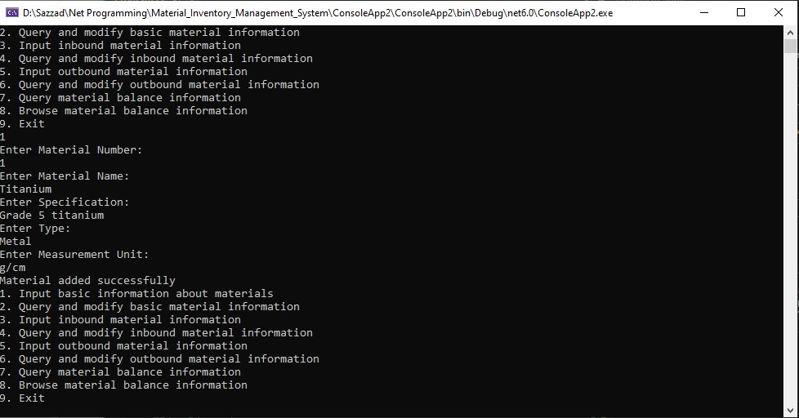

**Material 1 successfully added**

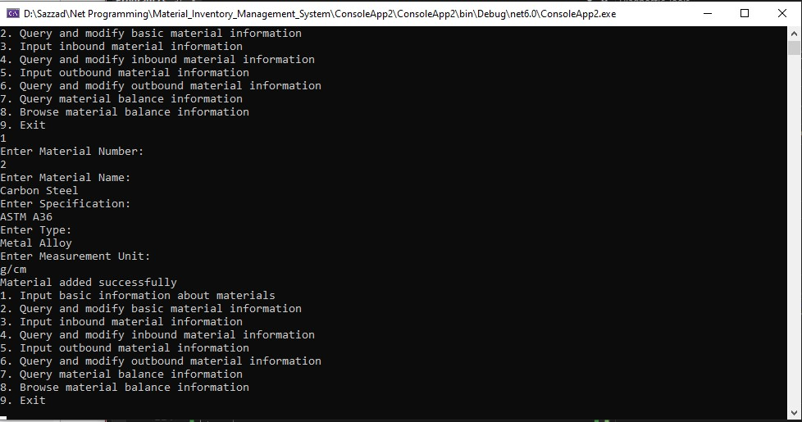

**Material 2 successfully added**

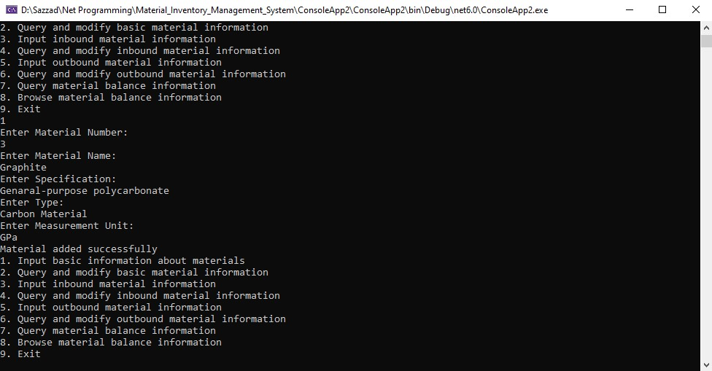

**Material 3 successfully added**

## 4.2 Query and modification of basic material information

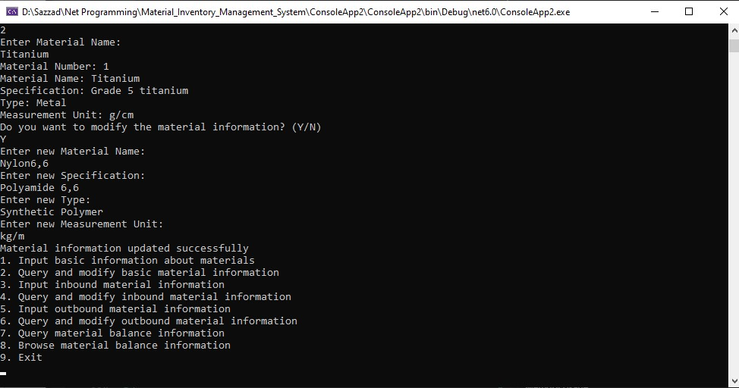

**Material queried and modified successfully**

## 4.3 Input of inbound material information

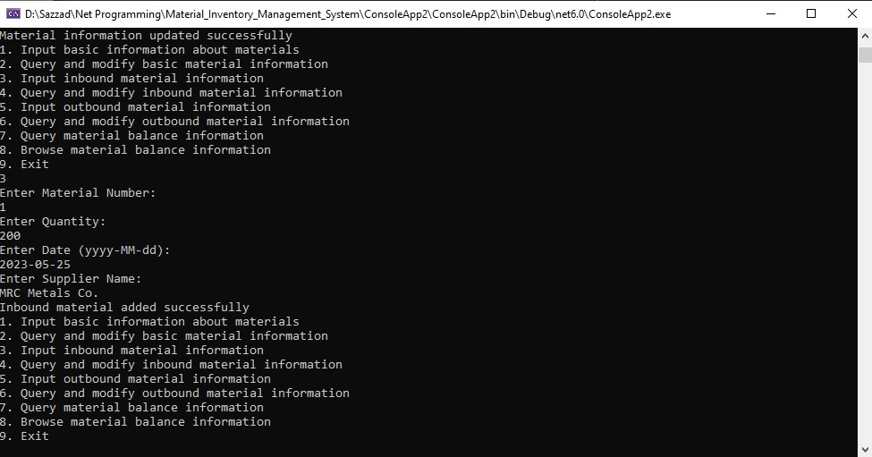

**Inbound Material 1 Successfully Added**

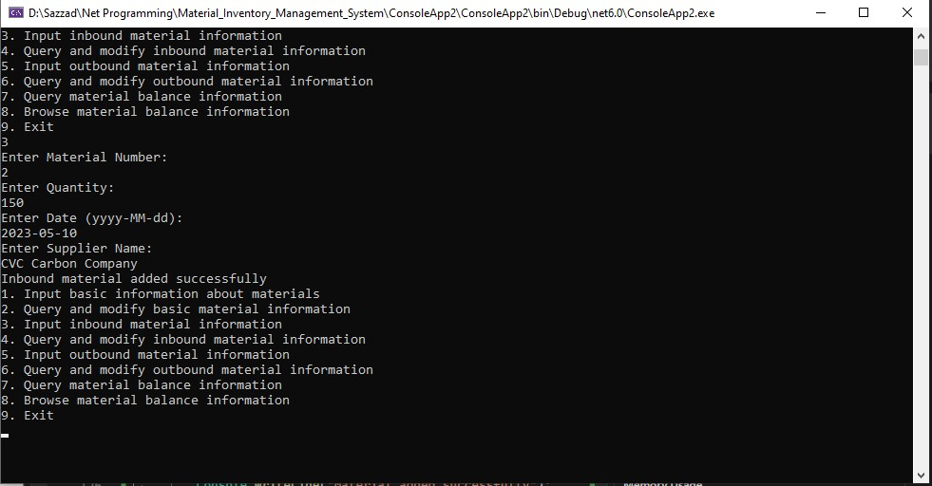

**Inbound Material 2 Successfully Added**

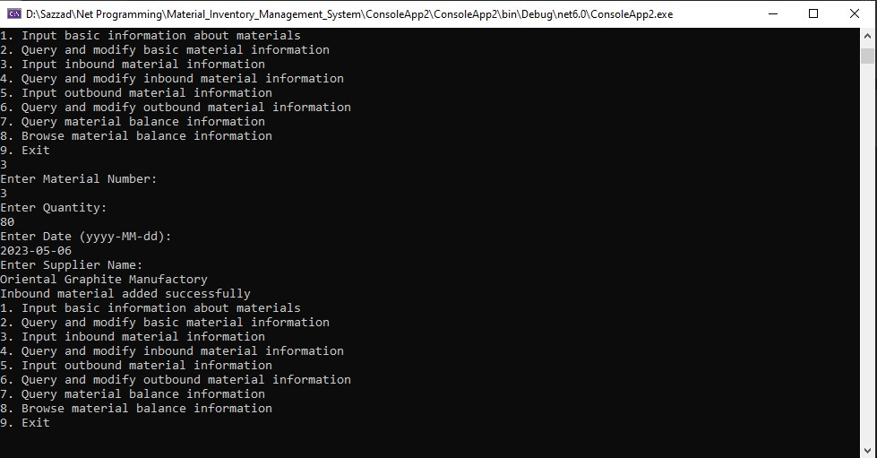

**Inbound Material 3 Successfully Added**

## 4.4 Query and modification of inbound material information

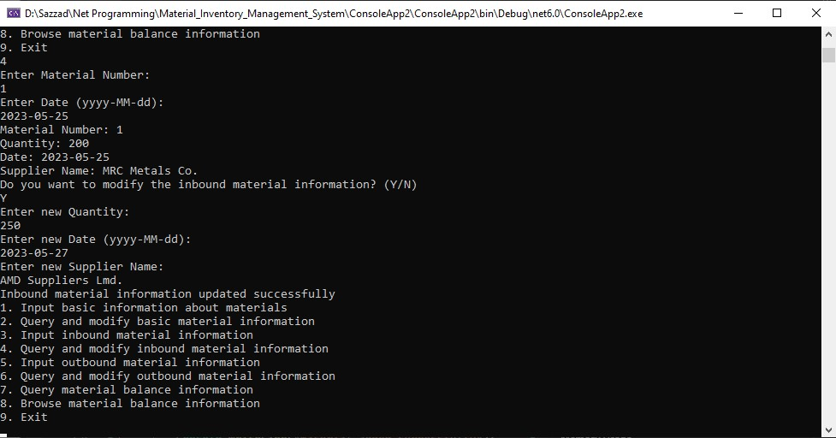

**Inbound material queried and modified successfully**

## 4.5 Input of outbound material information

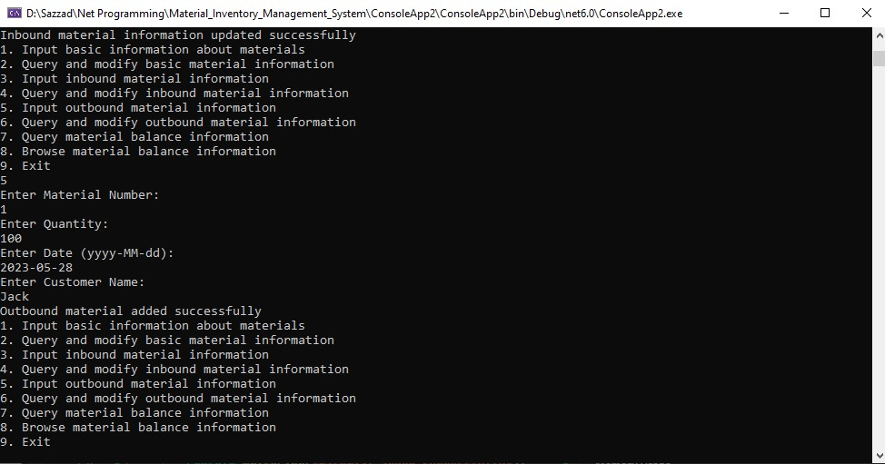

**Outbound Material 1 Successfully Added**

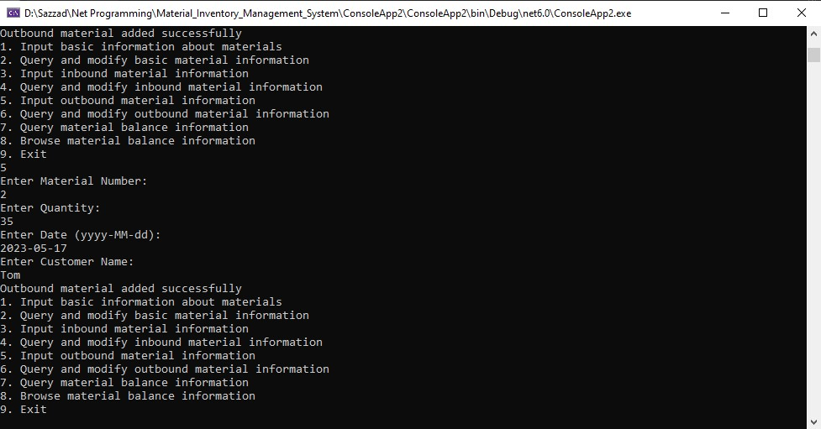

**Outbound Material 2 Successfully Added**

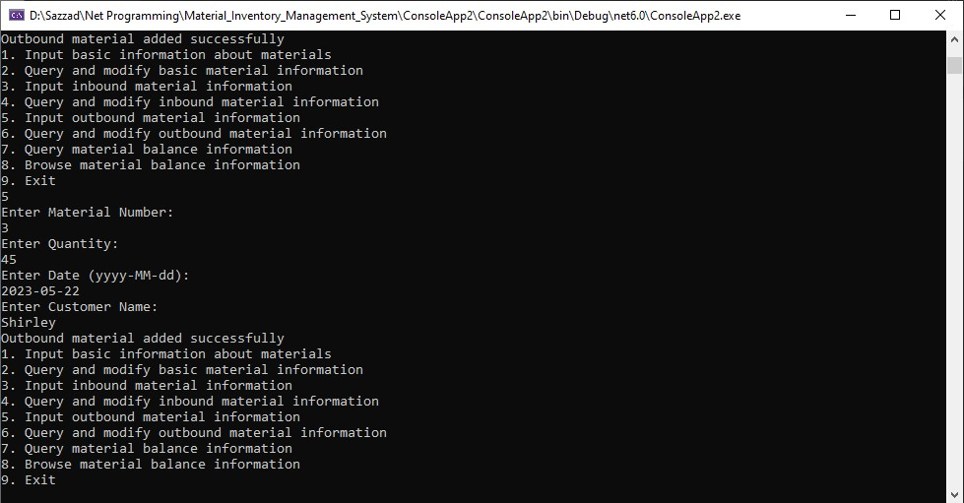

**Outbound Material 3 Successfully Added**

## 4.6 Query and modification of outbound material information

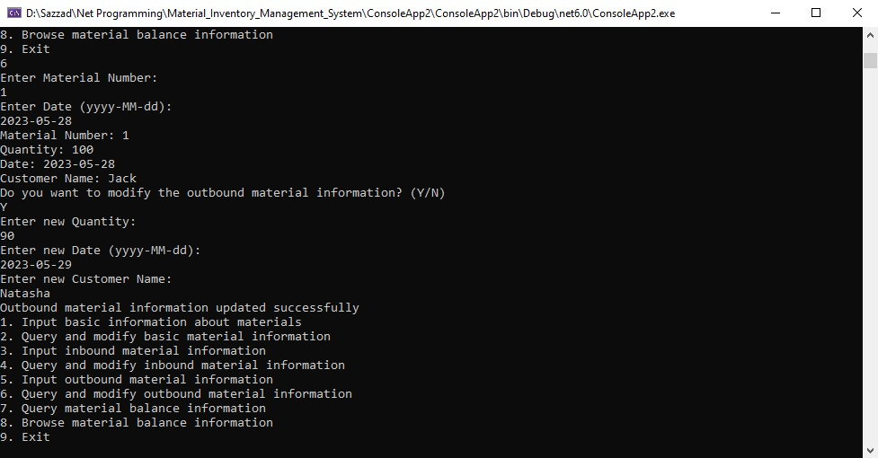

**Outbound material queried and modified successfully**

## 4.7 Query of material balance information

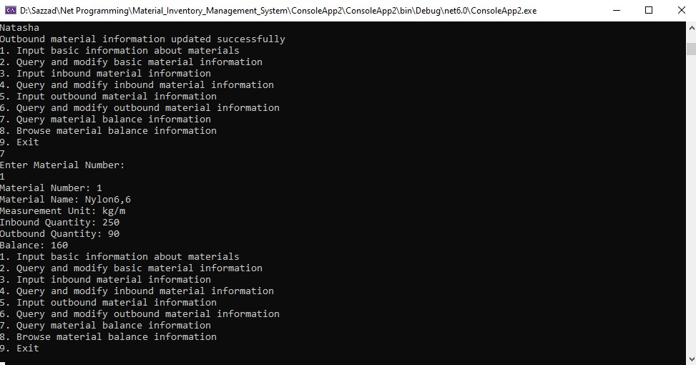

**Material 1 Balance Queried Successfully**

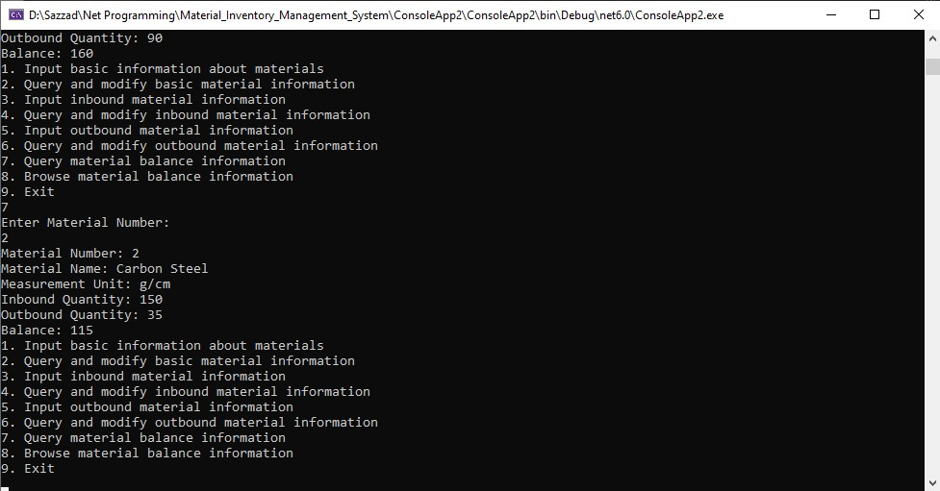

**Material 2 Balance Queried Successfully**

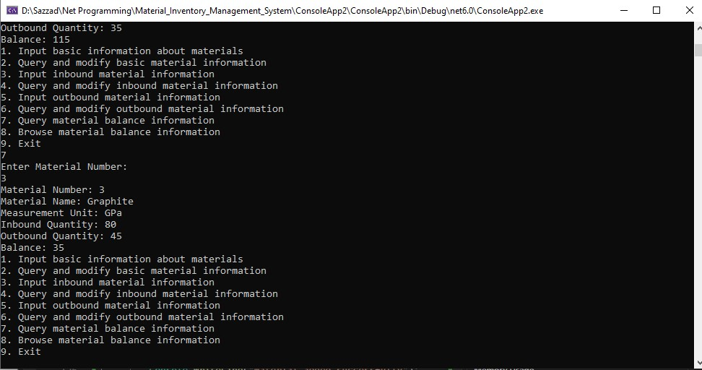

**Material 3 Balance Queried Successfully**

## 4.8 Browsing of material balance information

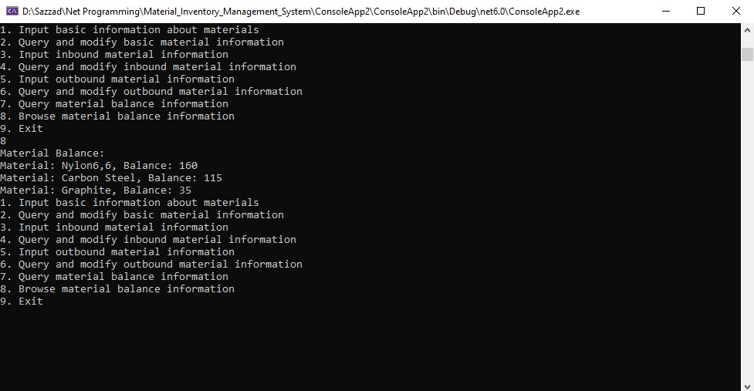

**Browsing material balance**

## 4.9 Exit from the system

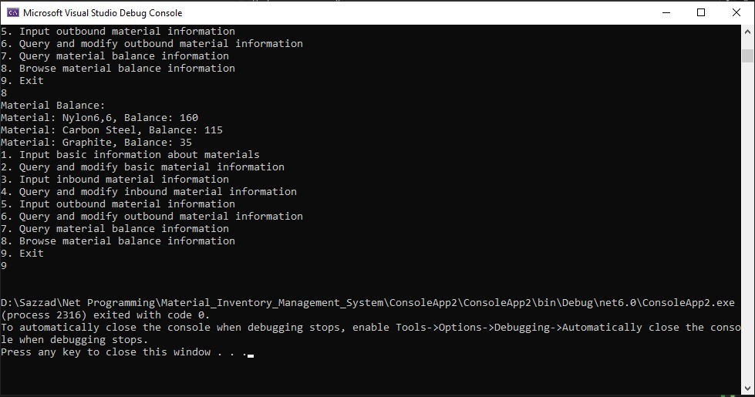

**Exit Successfully**

# CHAPTER 5: Conclusion

In this paper, the focus is on Material Inventory Management System and its significance in today's business operations. The study emphasizes the use of software and hardware tools to effectively manage inventory levels, track products, and monitor supply chain activities. By automating processes such as ordering, receiving, storing, and shipping, businesses can reduce costs associated with excess inventory, avoid stock outs, and improve customer satisfaction.

The paper acknowledges that Material Inventory Management System is not a one-size-fits-all solution, as its effectiveness depends on various factors such as the nature of the business, product characteristics, and complexity of the supply chain. Data accuracy is also highlighted as a crucial aspect, emphasizing the need for continuous improvement and adaptation to changing market conditions.

Moreover, the paper underscores the relevance of Material Inventory Management System in the present business environment and its potential for the future. In an increasingly competitive and uncertain market, efficient inventory management practices are essential for businesses to remain profitable and competitive. Material Inventory Management System is presented as a viable solution to achieve this objective. Additionally, the paper anticipates that advancements in technology, such as Artificial Intelligence, Internet of Things, and Block chain, will revolutionize inventory management and further enhance the capabilities of Material Inventory Management System.

In conclusion, the article highlights the crucial part that Material Inventory Management System plays in maximizing inventory levels, cutting expenses, and raising customer satisfaction. It gives a thorough summary of the idea, highlights significant discoveries and ideas, and underlines the system's applicability in both the present and the near future. In order to increase their competitiveness and accomplish their strategic goals, organizations should investigate and adopt Material Inventory Management System, according to the paper's conclusion.